Contents
Contents i
1 Introduction 1
1.1 System Introduction 1
1.2 Background of the System 1
1.3 Objectives of the System 1
1.4 Significance of the System 1
2 Overall Description 2
2.1 Product Perspective 2
2.2 Product Scope 2
2.3 Product Functionality 2
2.4 Users and Characteristics 2
2.5 Operating Environment 2
3 Specific Requirements 3
3.1 Functional Requirements 3
3.2 Behaviour Requirements 3
3.3 External Interface Requirements 3
4 Other Non-functional Requirements 5
4.1 Performance Requirements 5
4.2 Safety and Security Requirements 5
4.3 Software Quality Attributes 5
5 Design Description 6
5.1 Composite Viewpoint 6
5.2 Logical Viewpoint 6
5.3 Information Viewpoint 6
5.4 Interaction Viewpoint 6
5.5 State Dynamics Viewpoint 6
5.6 Algorithm Viewpoint 6

Introduction

System Introduction
The Event Management Website is a web-based platform that allows users to easily explore, register for, and manage various events such as seminars, concerts, workshops, and conferences. It simplifies event management for both organizers and participants by handling registrations, scheduling, and automated notifications through email, SMS, and WhatsApp after successful registration. The system’s main purpose is to make event handling smooth, user-friendly, and fully digital.

Background of the System
Existing platforms like Bookkaru mainly focus on event ticketing and sales for commercial purposes, often with high service fees and limited customization.
Our Event Management Website is built for universities, colleges, and small organizations that want to create and manage events easily without paying commissions. It is different because it provides simple event creation, participant management, and multi-channel notifications (email, SMS, WhatsApp) in one system. It’s designed to be lightweight, free, and adaptable to different event types.

Objectives of the System
• To provide an online platform for creating and managing events.
• To allow users to register for events and get confirmation instantly.
• To send automatic notifications via email, SMS, and WhatsApp.
• To help admins organize event details, participants, and schedules.
• To maintain a secure database of users and event records.
• To make event registration fast, transparent, and easy to track.

Significance of the System
This system removes the need for manual event registration and paperwork. It can be used for:
- University and College Events (seminars, workshops, orientations)
- Concerts and Social Gatherings
- Corporate Training Programs
- Community Events and Conferences
It’s important because it saves time, prevents errors, and keeps all event-related data organized and accessible from anywhere.

Overall Description

Product Perspective
The Event Management Website is a new, standalone system designed to manage all event-related operations. It connects users (participants) and organizers through a single platform. It also interacts with SMTP servers (for emails) and SMS/WhatsApp APIs for sending confirmations and updates.
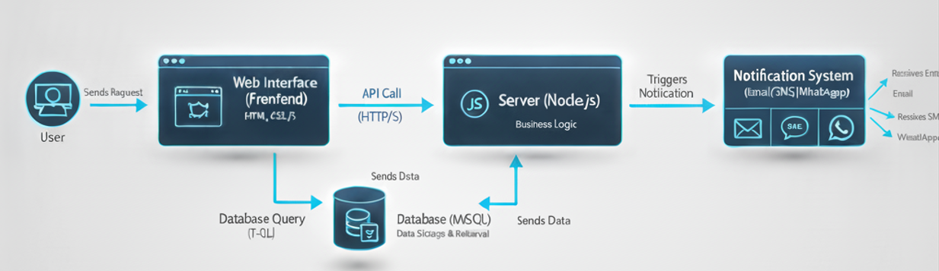
Fig-2.1 General Flow Diagram of System

Product Scope
The Event Management Website is an online platform that helps organizers create and manage events while allowing users to view details and register easily. It automates confirmation messages through email, SMS, and WhatsApp and securely stores all events and participant data.
The system focuses on event registration, management, and notifications. It does not include online payment, ticket pricing, or promotional features in this version. Future upgrades may add these functions to extend their capabilities.

Product Functionality
• User registration and login.
• Admin panel for creating and managing events.
• Event search and filtering.
• Participant registration form.
• Automated email/SMS/WhatsApp notifications.
• Database for storing events and participant data.
• Event update and deletion options for admins.

Users and Characteristics
1. Admin:
The Admin has the highest level of control in the system. They can approve or reject events created by organizers, manage all users, and monitor overall system activity. Admins ensure that only verified and valid events are published on the platform.
2. Organizer:
Organizers can create, edit, and manage their own events after admin approval. They can view participant lists, update event details, and send updates or reminders to register users.
3. User (Participant):
Users can browse approved events, view event details, and register online. After registration, they receive confirmation through email, SMS, or WhatsApp.
All interfaces are designed to be simple, responsive, and user-friendly, ensuring that even users with basic technical knowledge can easily interact with the system.

Operating Environment
• Frontend: HTML, CSS, JavaScript
• Backend: Node.js (Express Framework)
• Database: MSSQL Server
• Operating System: Windows / Linux
• Other Requirements: Internet connection, modern web browser (Chrome, Edge, Firefox)

Specific Requirements

Functional Requirements
3.1.1 Admin Functions
- User Management:
  - View, edit, and delete user accounts.
  - Approve or block organizers.
- Event Approval:
  - Review events submitted by organizers.
  - Approve or reject events before publishing.
- System Monitoring:
  - View total users, events, and registrations in the dashboard.
  - Generate reports for overall activity.
- Security Control:
  - Manage login credentials and enforce secure authentication.
3.1.2 Organizer Functions
- Event Creation and Management:
  - Create new events with details like title, date, venue, and description.
  - Edit or delete events before or after approval.
- Participant Management:
  - View lists of registered participants.
  - Send event updates or reminders through notifications.
- Profile Management:
  - Update organizer profile and contact details.
3.1.3 User (Participant) Functions
- Registration and Login:
  - Create an account and securely log in to the system.
- Event Browsing:
  - View all approved events with filters for date, type, or location.
- Event Registration:
  - Register for any active event.
  - Receive confirmation through email, SMS, or WhatsApp.
- Profile Management:
  - Update personal details and view past registrations.

Behaviour Requirements

Admin – Use Cases
- Approve / Reject Events – Review events submitted by organizers and decide their status.
- Manage Users – Add, edit, block, or delete users and organizers.
- View Reports / Dashboard – See system statistics like total events, users, and registrations.
- Send Notifications – Communicate important updates or alerts to organizers or users.

Organizer – Use Cases
- Create Event – Add new events with details (title, date, venue, description, etc.).
- Edit / Delete Event – Modify or remove events they have created.
- View Participants – See the list of users registered for their events.
- Send Notifications – Send updates or reminders to participants.

User (Participant) – Use Cases
- View Events – Browse all approved events by date, category, or location.
- Register for Event – Fill out the registration form to join an event.
- Receive Notifications – Get confirmation or update messages via email, SMS, or WhatsApp.
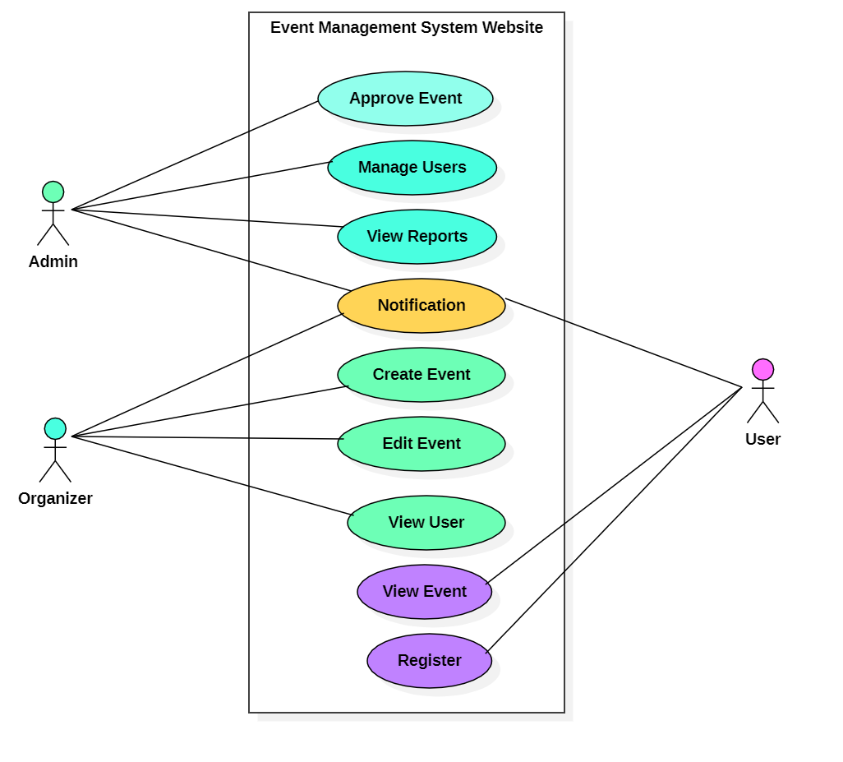
Fig-3.1 Use Case Diagram

External Interface Requirements

User Interfaces
The Event Management Website provides a clean, responsive, and user-friendly interface for all three types of users — Admin, Organizer, and User (Participant).
Main Interfaces:
- Login / Registration Page:
Allows users, organizers, and admins to log in securely or sign up. It includes fields for email, password, and role selection. Error messages appear for invalid credentials.
- Home Page:
Displays upcoming approved events with details like event name, date, venue, and description. Users can filter or search events easily.
- Event Details Page:
Shows complete event information with a “Register Now” button for users.
- Registration Form:
Collects user details for event registration and displays confirmation after submission.
- Admin Dashboard:
Includes event approval panel, user management section, and system overview cards showing total events, organizers, and participants.
- Organizer Dashboard:
Contains options to create, edit, and delete events, view participants, and send notifications.
Standard Elements:
- Buttons: Submit, Cancel, Update, Delete, Approve, Reject
- Alerts: Success or error messages displayed in pop-up or inline formats
- Navigation: Sidebar and top bar for easy access across sections

Hardware Interfaces
The system does not require any special hardware. It runs on standard computing devices such as desktops, laptops, or smartphones with an active internet connection. A basic keyboard and mouse (or touchscreen) are sufficient for all interactions.
No specialized hardware libraries or interfaces are needed for this project.

Software Interfaces
The system interacts with the following software components:
- Operating System: Compatible with Windows, Linux, and macOS.
- Database: MSSQL Server (for storing users, events, and registrations).
- Backend: Node.js (Express framework) for handling requests and logic.
- Frontend: HTML, CSS, and JavaScript for the user interface.

Communications Interfaces
The system communicates using standard HTTP/HTTPS protocols between client and server. All user requests and responses are sent securely using HTTPS to protect data in transit.
For notifications, the system uses:
- SMTP protocol for sending emails via a free email service (e.g., Gmail SMTP or Sendinblue free plan).
- Firebase Cloud Messaging (FCM) or OneSignal for push notifications instead of paid SMS/WhatsApp services.
The system uses Microsoft SQL Server (MSSQL) for database management, ensuring secure and reliable data storage.
All data transfers are encrypted to ensure privacy and security. The system requires an active internet connection for proper synchronization between the web server, database, and notification services.

Other Non-functional Requirements

Performance Requirements
<If there are performance requirements for the product under various circumstances, state them here and explain their rationale, to help the developers understand the intent and make suitable design choices. Specify the timing relationships for real time systems. Make such requirements as specific as possible. You may need to state performance requirements for individual functional requirements or features.
TO DO: Provide different performance requirements based on the information you collected from the client. For example you can say “1. Any transaction will not take more than 10 seconds, etc…>

Safety and Security Requirements
<Specify those requirements that are concerned with possible loss, damage, or harm that could result from the use of the product. Define any safeguards or actions that must be taken, as well as actions that must be prevented. Refer to any external policies or regulations that state safety issues that affect the product’s design or use. Define any safety certifications that must be satisfied. Specify any requirements regarding security or privacy issues surrounding use of the product or protection of the data used or created by the product. Define any user identity authentication requirements.
TODO:
Provide at least different safety requirements based on your interview with the client Describe briefly what level of security is expected from this product by your client and provide a bulleted (or numbered) list of the major security requirements.>

Software Quality Attributes
<Specify any additional quality characteristics for the product that will be important to either the customers or the developers. Some to consider are: adaptability, availability, correctness, flexibility, interoperability, maintainability, portability, reliability, reusability, robustness, testability, and usability. Write these to be specific, quantitative, and verifiable when possible. At the least, clarify the relative preferences for various attributes, such as ease of use over ease of learning.
TODO: Use subsections (e.g., 4.3.1 Reliability, 4.3.2 Portability, etc…) provide requirements related to the different software quality attributes. Make sure, that you do not just write “This software shall be maintainable…” Indicate how you plan to achieve it, & etc…Do not forget to include such attributes as the design for change. Please note that you need to include quality attributes.>

Design Description

Composite Viewpoint
<It identifies the major design constituents of system under study, for instance, composition and modular assembly of systems in terms of subsystems. The UML diagrams used to serve the purpose are “Package Diagram (Logical)”, and “Deployment Diagram (Physical)”.
TO DO: Package Diagram or Deployment Diagram of the complete system>

Logical Viewpoint
<The purpose of the Logical Viewpoint is to elaborate existing and designed types and their implementations as classes and interfaces with their structural static relationships, for instance, static structure (Classes, Interfaces and their relationships). The UML diagram used to serve the purpose is class diagram.
TO DO: a complete class diagram of software>

Information Viewpoint
<The Information Viewpoint is applicable when there is a substantial persistent data content expected in system under study. The UML diagram used to serve the purpose is Entity Relationship Diagram (ERD).
TO DO: Entity Relationship Diagram (ERD) in case of software having database for information storage>

Interaction Viewpoint
<The Interaction Viewpoint defines strategies for interaction among objects. This could include designing with concurrent tasks and/or asynchronous messaging, messaging among objects, etc. The UML diagram used to serve the purpose is Sequence Diagram.
TO DO: Provide sequence diagrams for every use-case>

State Dynamics Viewpoint
<The State Dynamic Viewpoint expresses the Dynamic state transformations of the system under study. The UML diagrams used to serve the purpose are UML State Machine Diagram, State Transition Table (Matrix).
TO DO: UML State Machine Diagram/ State Transition Table (Matrix) for the software>

Algorithm Viewpoint
<The detailed design description of operations (methods, functions), this applies to components, classes, and individual methods as design entities. The UML diagrams used to serve the purpose are Decision Table, Pseudo Code.
TO DO: Provide Decision Table or Pseudo Code for the complete software>

